DATA VISUALIZATION
- Order Status Count

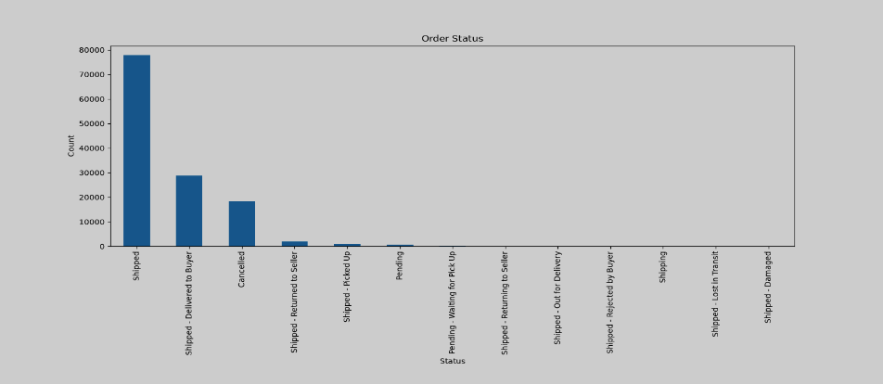
Most orders are shipped successfully.

- Top 10 Categories

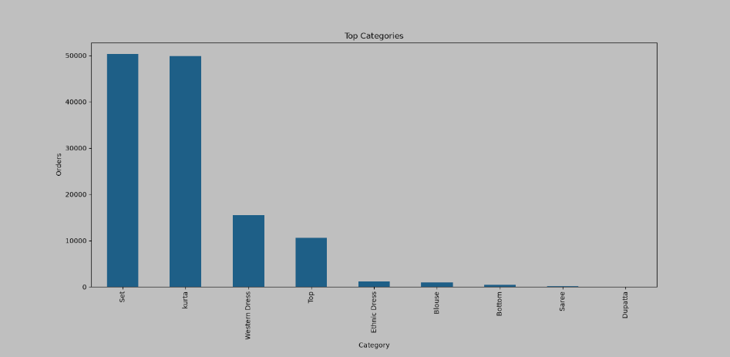
A few product categories have the highest number of orders.

- Top 10 States.

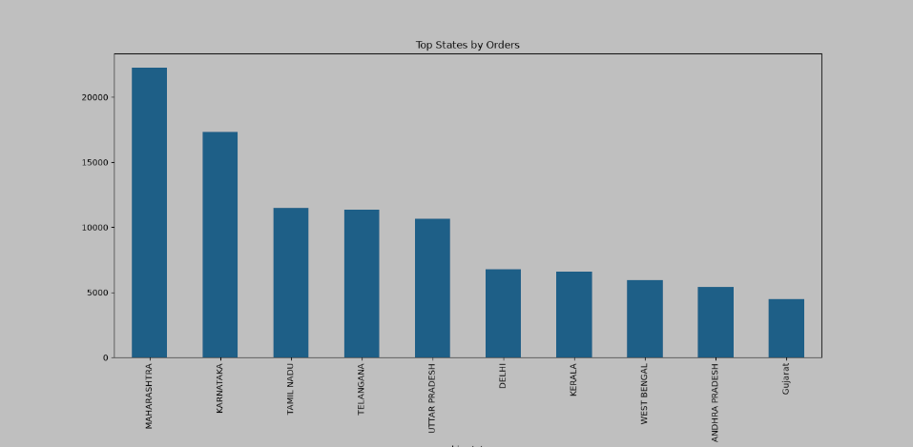
Some states generate more orders than others.

- Sales Distribution.

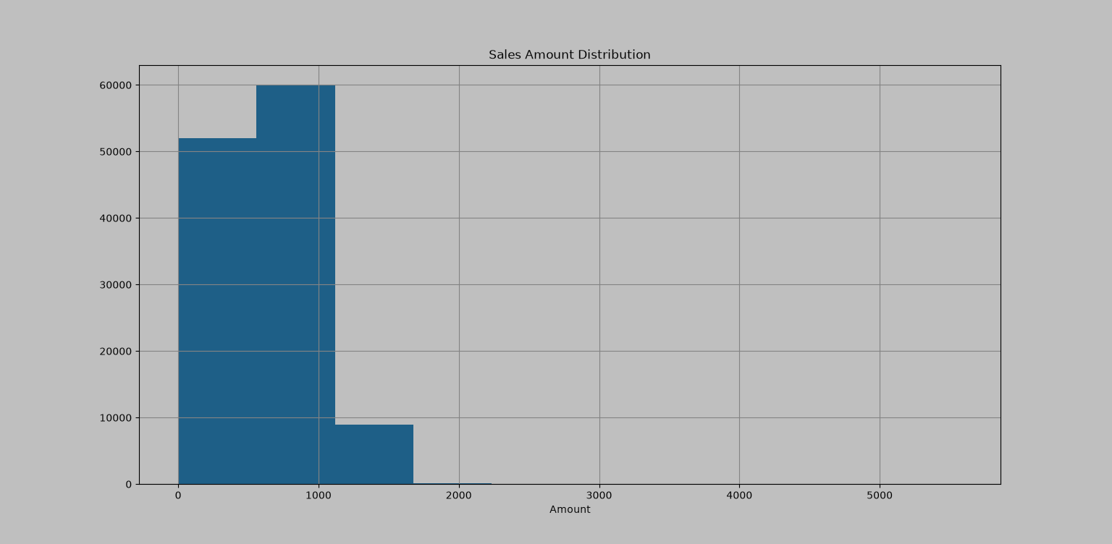
Most sales amounts are small, with only a few high-value orders.

- Fulfilment Type.

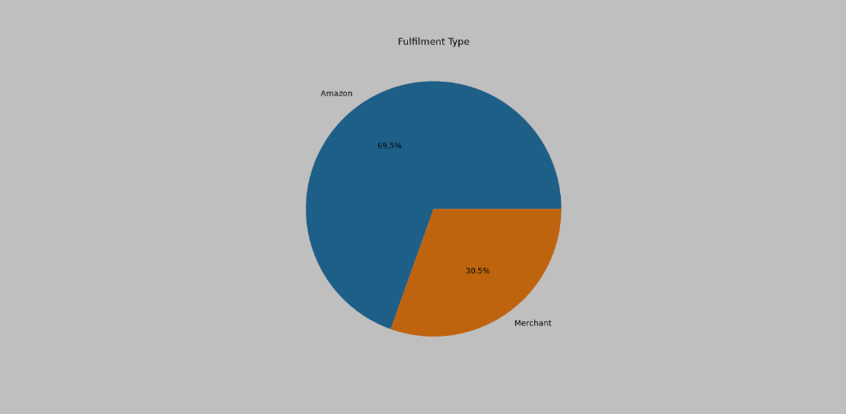
One fulfilment method dominates the order processing.

